

**2018-2019 Spring**

**CS 353-Database Systems**

**Company Interview and Employment Review Platform**

**Project Proposal**

**Group 4**

**Group Members**

Mehmet EgeAcıcan - 21602186 Section03

Koray Gürses - 21401254 Section01

GülnihalMuslu - 21502606 Section01

Can Ozan Kaş - 21501228 Section02

**Teaching Asistant**

Mustafa Can Çavdar

**Due Date:** 04.03.2019

**Table of Contents**

1. **Project Introduction………………………………………………………………………….3**
2. **Description of The System…………………………………………………………………3**
   1. **Basic Description……………………………………………………………………..3**
   2. **Why a Database is Required in this System……………………………..3**
3. **Functional Requirements……………………………………………………………………4**

**3.1 User……………………………………………………………………………………………...4**

**3.2 Company………………………………………………………………………………………4**

**3.3 Admin……………………………………………………………………………………………4**

**3.4 Requirements that apply for all…………………………………………………….5**

1. **Non-Functional Requirements…………………………………………………………….5**

**4.1 Usability………………………………………………………………………………………..5**

**4.2 Capacity………………………………………………………………………………………..5**

**4.3 Security…………………………………………………………………………………………5**

**4.4 Reliability………………………………………………………………………………………6**

1. **Constraints………………………………………………………………………………………….6**
2. **Limitations………………………………………………………………………………………….6**
3. **Conceptual Design……………………………………………………………………………...7**
   1. **E/R Diagram……..……………………………………………………………………….7**
   2. **Notes on the E/R Diagram………………………..………………………………8**
4. **Logical Design……………………………………………………………………………………..8**
5. **Conclusion…………………………………………………………………………………………..9**
6. **Website……………………………………………………………………………………………….9**

**1.Project Introduction**

The following is a project proposal of a Company Interview Website Data System. The proposal will include: brief description of the soon-to-be created program, Funcitonal and Non-functional requirements of the database and finally, it will include the Conceptual Design and Logical Design of the Database. Conceptual Design will include E/R Diagram of the Database and Notes about the diagram while the Logical Design will include the tables of the Database based from the E/R Diagram.

The proposal outline starts with the Project description, which will try to explain what the database system is about and why it is required in this project. After the description, the system requirements will be categorized as functional and non functional requirements and will be discussed separetely. These discussions will be followed by the conceptual design which will show the E/R diagram and discuss specific topics about it. Finally, the proposal will have Logical Design part that will show the tables of the Database System.

**2.Description of the System**

**2.a Basic Description:**Our team proposes a Company Interview and Review Platform. A system similar to the Glassdoor job finding website or LinkedIn resume website. With the help of our platform, users would be able to search and apply for a specific job and the companies would be able to hire or refuse specific users for themselves. Users are also able to share their informations about themselves and they are able tos hare their resume in the platform as well. Along with the users, the companies will also have their own “resume”, based on the reviews of the users. However, specific reviews can be removed by the admins if the admin accepts the request made by the company. So, basically this platform is an online Company and Employee review platform that allows the users to choose a specific job and companies to a specific person. Along with this, it is also a resume (Person and Company) sharing platform.

**2.b Why a Database is Required in this System:**A platform like this would definitely need a databasesystem because the whole platform works by reviewing the kept information of the companies accounts and the employee’s accounts. The information number can also be quite large( Considering the companies will hire users with more experience, more awards and more skills just as the users would prefer to apply for companies with more connections, more successes and more job offerings. Therefore, a simple program written in a specific High Level language may not be enough to keep all those data and change them whenever it is necessary.

**3. Functional Requirements**

**3.1 Users**

**3.1.1** Users should be able to arrange their profile information

**3.1.2** Users should be able to arrange the information in their resumes

**3.1.3** Users should be able to share their resumes with Companies

**3.1.4** If desired, users should be able to share their resumes anonymously.

**3.1.5** Users shuold be able to follow companies that they want to follow

**3.1.6** Users should be able to ask to Admins in order to delete specific pros or cons about them.

**3.1.7** Users should be able to look at the resumes of the Companies

**3.1.8** Users should be able to apply for a job of the companies

**3.2 Companies**

**3.2.1** Companies should be able to offer a job

**3.2.2** Companies should be have company resumes that describes specific details about them

**3.2.3** Companies should be able to ask to Admins in order to delete specific pros or cons about them.

**3.3 Admins**

**3.3.1** Admins should be able to accept or reject specific requests for pros/cons deletion made by the users or companies

**3.4 Requirement that Apply for All**

**3.4.1 Profile Saving and Profile Update**: The users should be able to save and update their profile whenever they desire. The data that is going to be held should be chosen by the user.

**3.4.2 Sign-up and Log in:** Users, Companies and Admins should be able to register to the site if they desire and they should be able to log in with the specific password that they choose.

**4. Non-Functional Requirements**

**4.1 Usability**

The whole system should be easy to understand and use. The users should be able to use all the proposed functions easily.

**4.2 Capacity**

Database should be able to contain large amounts of data without creating a problem.

**4.3 Security**

The information that the users or companies share should be able to be protected. The data privacy to both should be offered.

**4.4 Reliability**

The system should be able to perform the given tasks without creating a problem.

**5.Constraints**

As Structured Query Language, MySQL will be used.

As for frontend and backend development, PHP will be used.

As for being able to allow user to modify data in the database, for connecting MySQL and PHP, will be used.

**6. Limitations**

1. A user is free to delete an account whenever he/she desires. If this happens, all information of the users will be deleted.

2. A user can only comment about 5000 characters.

3. If Admin rejects the deletion of a review, A company or a user can ask for the deletion of the review again. However, a company cannot ask more than 3 deletions in a month.

4. When a user account is banned or suspended, he/she cannot login during the suspend time

5. Users can not be banned infinitely. They can only close their account permanently, only if they want to.

**7. Conceptual Design**

**7.a E/R Diagram**

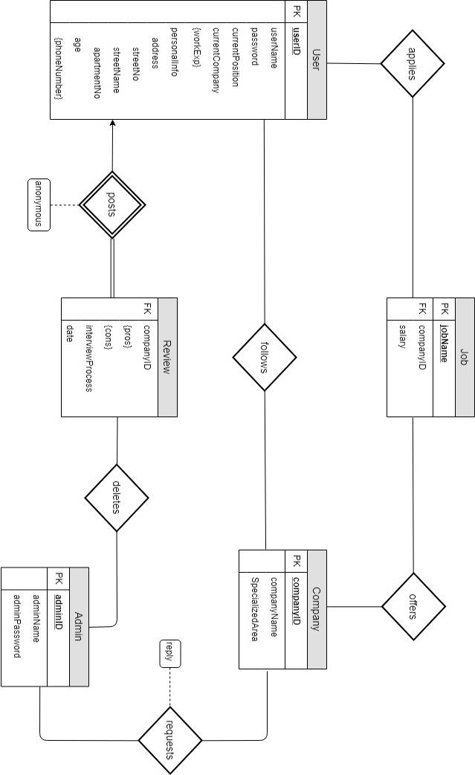

**7.b Notes about the E/R Diagram:**

Multiple users and multiple companies can have the same password. Only ID’s allow the uniqueness.

This E/R diagram is open to change, in the later development of the project, E/R diagram can be changed and if this occurs, the change will be announced in the website

It is assumed that every job in the specific company is unique, thus there is no jobID as a primary key, only job name

1. **Logical Design**

Below, there are the tables that the database should contain along with their primary keys and if they have, foreign keys.

User(userID, userName, password, currentPosition, currentCompany, streetNo, streetName, apartmentNo, age, phoneNumber, workExp)

Company(companyID,companyName,specializedArea)

Follows(userID, companyID)

Admin(adminID,adminName,adminPassword)

Offers(CompanyID,userID)

Apply(userID,jobName)

Job(jobName,companyID,salary) FK: companyID ref Company

Review(userID,companyID,pros,cons,interviewProcess,date,anonymous)

Delete(adminID,companyID)

Request(companyID,adminID,reply)

1. **Conclusion**

This Proposal tries to explain the structure of the system, specifically, the structure of the Database that the system contains. The functional, non functional requirements should be able to allow contribution to the later implementation of the Project. While doing the Project, besides the requirements that have been explained in this proposal, certain limitation can occur and specific additions can be made. These updates will be given in our web link.

**10 Website**

All the changes and updates to the Project will be given in the following website: https://github.com/gmuslu/CS353/tree/master/doc